UCOLD YOUNG PROFESSIONALS FORUM (YPF)
UCOLD YPF
The UCOLD Young Professionals Forum (YPF) is a platform for early-career professionals and students (40 years and below) to engage in dam safety, hydropower development, and water resources management. It aligns with the ICOLD YPF and aims to inspire, connect, and empower the next generation of professionals under UCOLD.
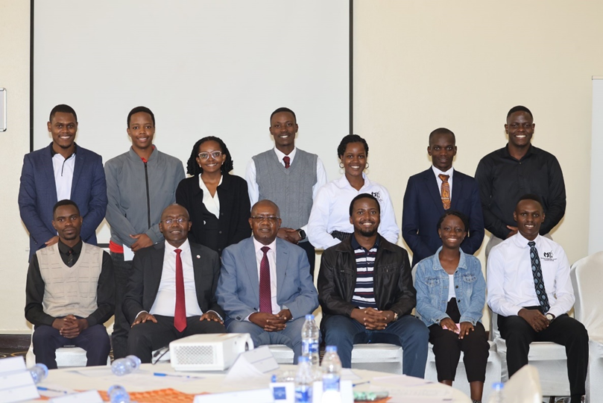
ICOLD YPF
The ICOLD Young Professionals Forum (YPF) provides a global platform for young professionals to exchange knowledge, build networks, and engage in intergenerational dialogue within the ICOLD community. Originally launched as the Young Engineers Forum (YEF), the initiative was proposed in 2009, approved by the ICOLD Board in 2010, and later rebranded to YPF to include a broader range of disciplines beyond engineering.
A seven-member international board leads the forum. Uganda is proudly represented by Wilberforce MANIRAKIZA, who served as a board member from 2022 to 2024. Learn more on the ICOLD YPF official web page.
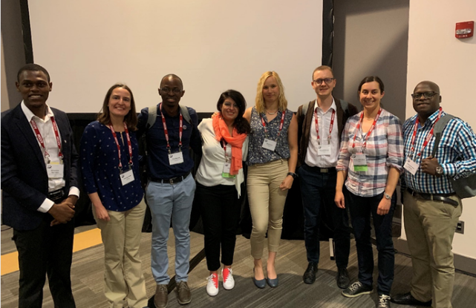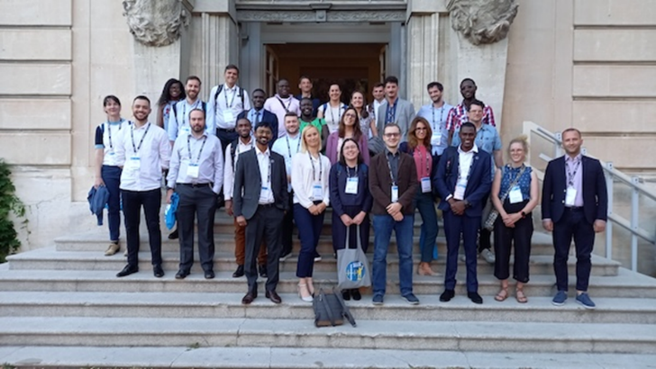
UCOLD YPF Executive Committee
The UCOLD YPF Executive Committee is composed of five members, including the Chairperson, Vice Chairperson, and three Secretaries responsible for Technical, Media, and Coordination roles. Committee members are elected for a three-year term and are responsible for driving the forum’s vision, activities, and engagement with national and international stakeholders.
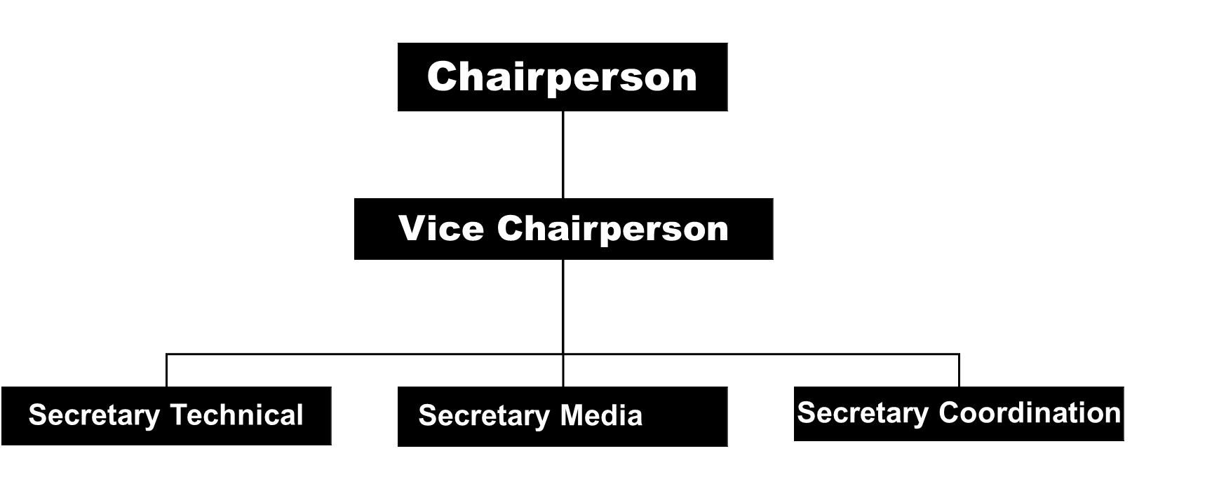
Corporate Platforms
We maintain active LinkedIn groups at the national, regional, and international levels. If you’re interested, please request to join. If eligible, your request will be approved by the group admin.
UCOLD YPF LinkedIn Group: https://www.linkedin.com/groups/9069759/
ICOLD ARC YPF LinkedIn Group: https://www.linkedin.com/groups/9248089/
ICOLD YPF LinkedIn Group: https://www.linkedin.com/groups/4679910/
ICOLD YPF YouTube Channel: https://www.youtube.com/channel/UC05fqnmx6rKKmXSkG3-fnSw/featured
Events & Benefits
- National and International webinars
- Workshops especially for the YPF
- Networking events
- YPF paper and poster award at ICOLD annual meetings
- Reduced fee to attend ICOLD annual meetings
- Mentorship opportunities and mentorship round tables
- YPF social events
- Group discussions, networking activities - guidance and knowledge transfer
How to get involved?
If you're a Ugandan professional in the early stages of your career in the dam industry, we invite you to join us!
Expand your network, connect with peers, and help shape the future of Uganda’s dams community.
Follow our active social media platforms to stay updated on events and opportunities.
UCOLD X Handle: @UCOLD_Ug https://x.com/UCOLD_Ug/status/1937540899380047934
UCOLD LinkedIn Page: https://www.linkedin.com/company/36078271/admin/page-posts/published/
ICOLD ARC LinkedIn Page: https://www.linkedin.com/company/108178017/admin/page-posts/published/

